**EXPERIMENT-11**

**CONFIGURATION OF A SAMPLE STATIC ROUTING ROUTERS IN PACKET TRACER USING A SIMPLE TOPOLOGY**

**Aim:** To configure a router using packet tracer software and hence transmit data between the devices in real time mode and simulation mode.

**Software / Apparatus required:** Packet Tracer / End devices, Switches,

connectors.

**Requirements:**

1. End device - They are the devices through which we can pass message from one device

to another and they are interconnected.

2 Switch/Hub - Interface Between two devices.

3. Cable - Used to connect two devices

**Procedure:**

STEP 1: Click on end devices, select generic Pc’s drag and drop it on the

window. Click on SWITCH drag and drop it on the window.

STEP 2: Select the straight through cable and connect all end device to switch. Assign the IP

address for all end devices. (Double click the end device Select →

desktop → IP configuration static)

STEP 3: Now set the IP address to Host A (192.168.1.1) in static mode. Similarly set IP address

for Host B (192.168.1.2) and Host C (192.168.1.3)

STEP 4: To view the IP address, give ip config command in command prompt. Using ping

command, we can establish communication between two host devices.

STEP 5: Now display the packet transmission in simulation mode.

**Output:**

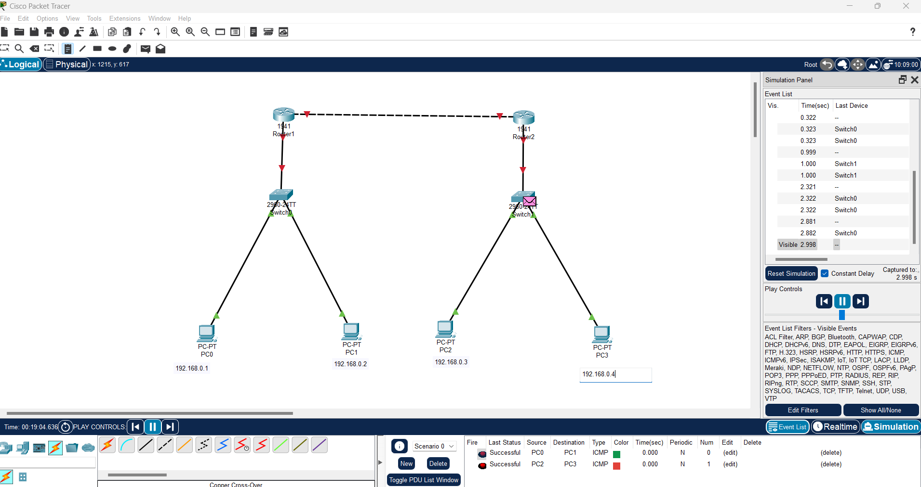

**RESULT:** Configuration of a sample static routing routers in packet tracer using a simple topology